**Extend CDS view**

1)Create base view.

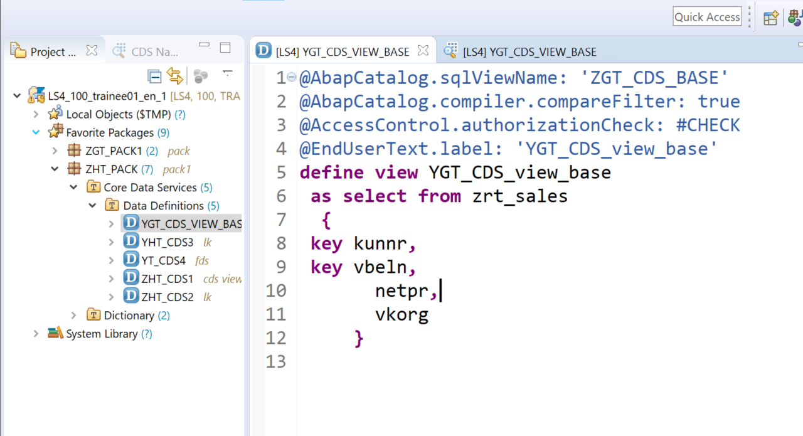

**define** **view** YGT_CDS_view_base

**as** **select** **from** zrt_sales

**{**

**key** kunnr**,**

**key** vbeln**,**

netpr**,**

vkorg

**}**

2)Check the view in SE11

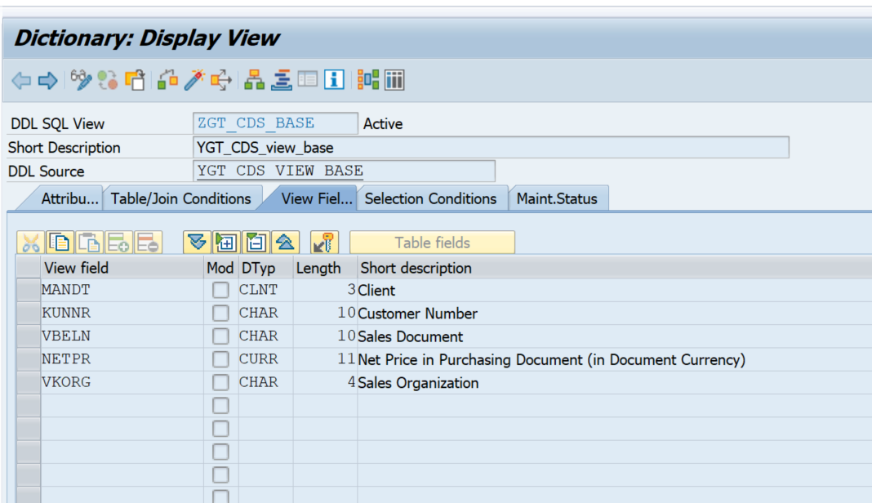

3) Task is to add one more field WAERS to the base view ZGT_CDS_BASE.

4)Create another CDS view called YGT_CDS_EXTEND

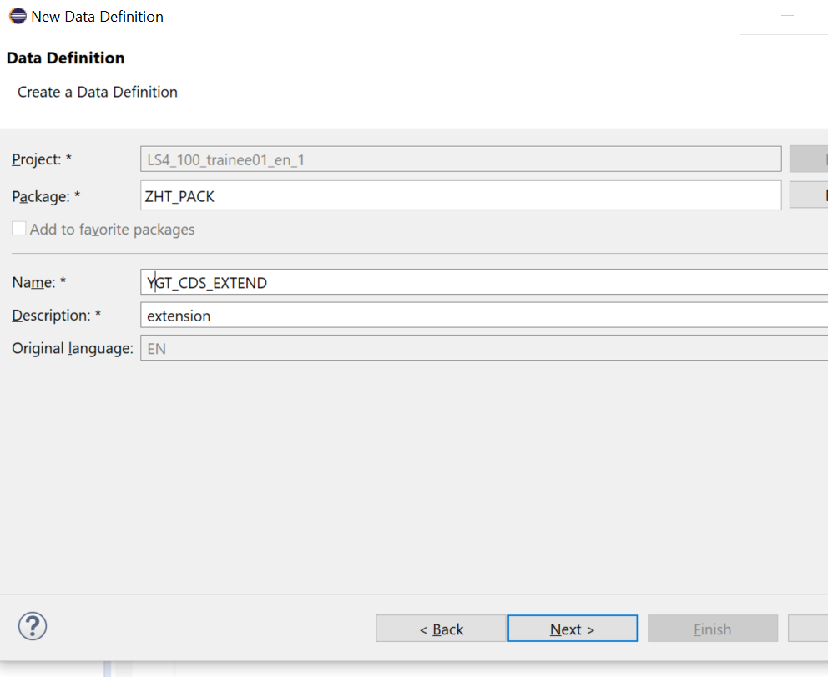

5) In the consequent screens choose the template for Extend view.

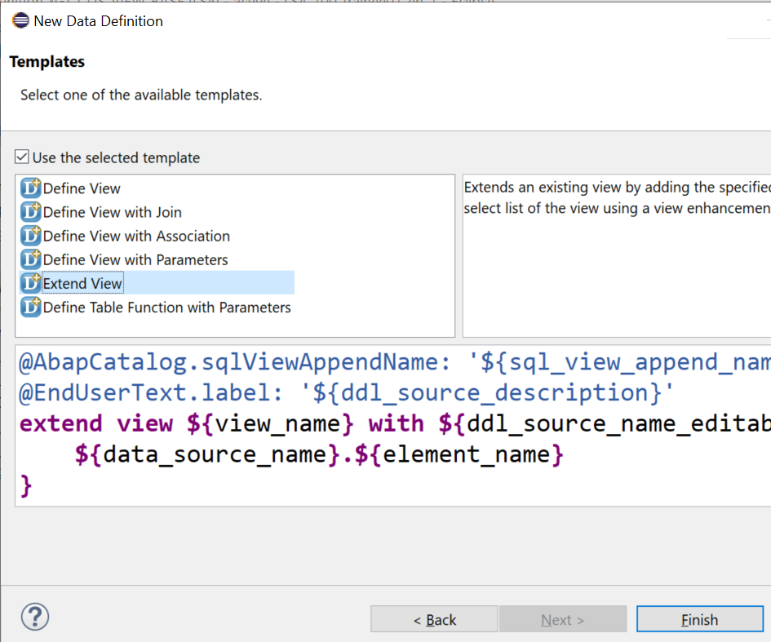

6) Edit the code as below.

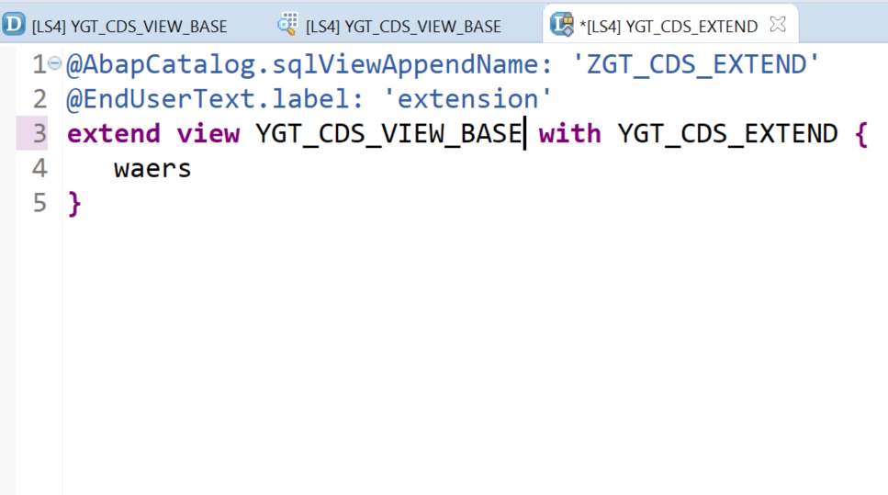

@AbapCatalog.sqlViewAppendName: 'ZGT_CDS_EXTEND'

@EndUserText.label: 'extension'

**extend** **view** YGT_CDS_VIEW_BASE **with** YGT_CDS_EXTEND **{**

waers

**}**

9) Save and activate the view YGT_CDS_EXTEND

10) Check the base view in SE11 ZGT_CDS_BASE, you will notice that the field WAERS is appended

